EMBEDDED SYSTEMS-ECA1401
EXP_1
CIRCUIT DIAGRAM:

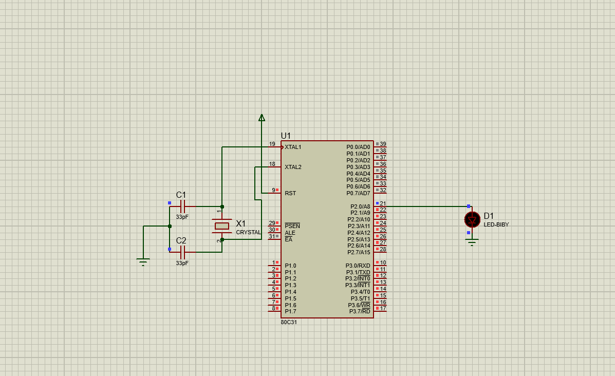
SOURCE CODE:

